Final Co-op Report

Tania Demonte Gonzalez

Mechanical Engineering

Academic Advisor: Dr. Gordon G. Parker

National Renewable Energy Laboratory

Golden, CO

Co-op Start 01/2023 - 04/2023

UN 5003

Cooperative Education III

# Supervisor Approval Form

Final Co-op Report

Student Name: Tania Demonte Gonzalez

Academic Major: Mechanical Engineering

Semester(s) on co-op: 1 on this project, 2 on another project.

Company: National Renewable Energy Lab

Company Address: 15013 Denver West Pkwy, Golden, CO 80401

Supervisor’s Name: Dr. Nathan Tom

Supervisor’s Title: Researcher IV - Mechanical Engineering

*I have read the above student’s final co-op report and agree that it does not contain any proprietary information. The report may now be submitted to the Cooperative Education Program within Michigan Technological University’s Career Services.*

**Supervisor’s Signature:**

**_______________________________________________**

## Supervisor’s Phone: 303-384-7159

## Email: Nathan.Tom@nrel.gov

**Date: 4/14/2023**

As the supervisor, if you have any questions or concerns regarding this student or the report, please contact Karen Logan, Co-op Instructor at Michigan Technological University at logan@mtu.edu

# I. Introduction

The National Renewable Energy Lab (NREL) located in Golden, Colorado is one of the US Department of Energy (DOE) 17 national research laboratories and it is the only one solely tasked with transforming energy using renewable resources [1]. The major research areas include renewable power sources such as solar, wind, water, and geothermal, sustainable transportation, energy efficiency and energy systems integrations. I am part of the hydropower and water systems deployment department where we develop renewable energy systems to design, evaluate and validate innovative and efficient water technologies.

My role as a graduate intern is to research and model a time-varying hydrodynamic model for a variable geometry wave energy converter (WEC). WECs are devices that transform the energy of the water waves into useful forms of energy, such as electricity. In order to reduce the cost of WEC devices that must be designed to withstand large loads, the concept of variable geometry WECs is being studied. By opening and closing the flaps of the WEC, one can reduce the structural loads in more energetic sea states, and therefore, reduce the cost of the produced energy.

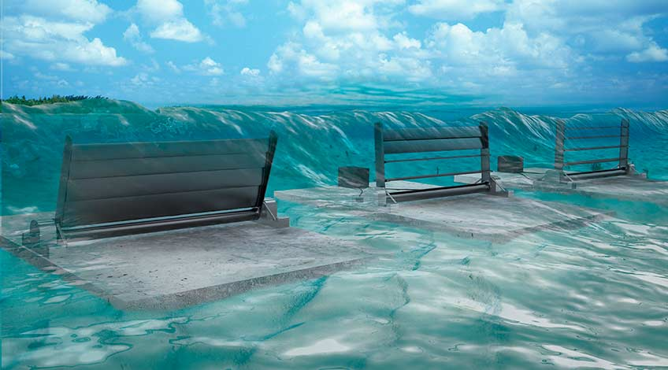

Figure 1. Wave Energy Converter with variable geometry control surface. Rendering by Josh Bauer, NREL.

# II. Projects

## Introduction

The negative effects of traditional energy sources on the environments have created the motivation to explore alternative energy sources. The technical power potential of U.S. marine energy resources is about 57% of the country [1]. However, marine energy technologies such as wave energy converters need to be optimized to go from government-funded research to commercialization. Recently, researchers at NREL have developed a variable geometry wave energy converter (VGWEC) that aims to improve the load-shedding capabilities of the WEC structure by controlling the pitch angle of the individual flaps as seen in Figure 1. Reducing the structural load will have a significant impact on the cost of WECs. My project is to develop a time-varying hydrodynamic model of the VGWEC to assess if the computational power used is worth when compared to modeling the VGWEC with static hydrodynamics.

## State-of-the-art

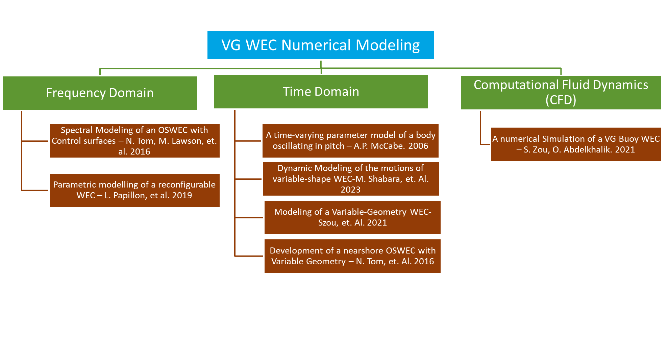Initially I did a lot of literature review to gain more knowledge in VGWEC and learn about the different approaches that researchers have used to model similar devices. Figure 2 is a categorized list of the

Figure 2. Literature Review Flowchart.

papers that I found relevant to this project. From the papers listed, my supervisor and I decided to start the modeling process following the approach presented by McCabe [2].

## Modeling

To facilitate the first stage of modeling, only one flap of the VGWEC was considered. The modeling process consisted of obtaining the hydrodynamic parameters of the flap at discrete angles of rotation of flap as shown in Figure 3. These parameters were obtained using a boundary element solver called WAMIT [3]. After all the data was collected and processed, the flap rotation was modeled by the widely used Cummins equation [4]. In the marine energy field, usually WECs are modeled using a fixed geometry with just 1 set of hydrodynamic parameters for a range of frequencies. However, in this model, as the flap angle changes because of the incoming waves, the hydrodynamic parameters change. To make this transition between discrete flap angles smooth, the hydrodynamic parameters were interpolated using least-square best fit.

Figure 3. Mesh of the singular flap on the left, and discrete flap rotations on the right.

## Results

The product of this semester’s work is primarily a working time-varying hydrodynamics wave energy converter model. The model was done in MATLAB and Simulink. In total, 3 different models were created: 1) single hydrodynamics model: in this model, the hydrodynamic parameters are constant, therefore not matter what is the rotation of the flap, the hydrodynamics will correspond to those of the flap at 0° which is the fully closed position. 2) discrete time-varying hydrodynamics: in this case the hydrodynamics will change with respect to the flap rotation at each discrete $θ$. 3) interpolated time-varying hydrodynamics: similarly, to the aforementioned model, the hydrodynamics will change with respect to the flap angle, however, in this case, the change will happen at a more fine $θ$ using a least-square best fit interpolation method.

The goal is to be able to determine if switching from a single to a time-varying hydrodynamics model is worth the computational effort. The models I developed will help the researchers at NREL assess the difference in load shedding between a conventional wave energy converter, and the novel variable-geometry wave energy converter. The models were uploaded to a GitHub repository where it can be accessed and download via a link.

# III. Co-op Evaluations

This section should be a minimum of 2 paragraphs. Review and reflect on both the Supervisor Progress Evaluation and the Supervisor Final Evaluation. In which areas did you improve during the semester? What methods did you use to improve? What are you most proud of? Which areas were your lowest on the final evaluation and what can you do in the future to work on those areas? If given the chance, what is something you would’ve changed?

# IV. Reflections on the Co-op Experience

My time at NREL has been an incredibly fulfilling and enriching experience. Beyond the opportunity to meet and work alongside individuals I had previously only read about; I was also able to immerse myself in the wonders of Colorado. I was fortune to have been a part of a company at the forefront of research and development in offshore technologies.

## Differences between co-ops

While all three of my previous internships were at NREL, this semester's experience was distinct, as I had the opportunity to collaborate with a fresh team on a new project. In the past, my work primarily centered around wave tank testing, an area in which I felt confident. However, this recent undertaking pushed me beyond my comfort zone and provided a valuable opportunity for me to acquire new skills. I now have a deeper understanding of the hydrodynamics of WECs and various modeling tools associated with them.

## Communication Skills

Comparing my current co-op to my first, I have noticed a significant improvement in my communication skills. With this semester's work being conducted fully remotely, I recognized that effective communication would be crucial to the success of my internship. In my previous internships, I would send bi-weekly emails to my supervisor, sharing my progress and outlining my plans for upcoming tasks. This time around, I opted for a different approach and put together a bi-weekly PowerPoint presentation for our meetings. I believe that this visual aid has proven to be immensely helpful for both my supervisor and me in tracking our progress and referencing past discussions.

## Working at NREL

In my time at NREL, I believe that one of the most valuable skills I acquired was the ability to work effectively within a national laboratory environment. I observed how national labs place a great emphasis on collaboration, frequently partnering with different universities, industry experts, and other national labs. I personally had a fantastic experience seeking assistance from other universities, and it was truly inspiring to feel the genuine desire of others to aid in the success of my project.

# V. Conclusion

In summary, this internship has provided me with both professional and personal growth. I have acquired a range of professional skills that would have been unlikely to be obtained in an academic setting, while also discovering new things about myself. This semester I had a lot of responsibilities, since I was TAing and researching for my own Ph.D. degree. However, I was able to manage my time very well to also have the opportunity to enjoy the winter during my leisure time.

As for my work in wave energy converters, I was introduced to this new concept of variable geometry WECs and I believe that this new concept has the potential to drive WECs to the commercialization stage. I personally gained a lot of knowledge in this field, and I believe that my contribution to NREL will be very valuable for the industry. I am looking forward to the advancement of this technology.

Finally, I would like to extend my gratitude to the teams I worked with during my year at NREL. My work would not have been successful without their help, and I will always be grateful for this opportunity.

# References

[1] Kilcher, Levi, Michelle Fogarty, and Michael Lawson. 2021. Marine Energy in the United States: An Overview of Opportunities. Golden, CO: National Renewable Energy Laboratory. NREL/TP-5700-78773. <https://www.nrel.gov/docs/fy21osti/78773.pdf>.

[2] A.P. McCabe, G.A. Aggidis, T.J. Stallard. 2006. A time-varying parameter model of a body oscillating in pitch, Applied Ocean Research, Volume 28, Issue 6, Pages 359-370, ISSN 0141-1187. <https://doi.org/10.1016/j.apor.2007.05.001>.

[3] WAMIT user manual. Chestnut Hill (MA, USA): WAMIT Inc.; 2002. p. 2467–504.

[4] Cummins WF. The impulse response function and ship motions. Schiffstechnik 1962;9(47):101–9.